**Power BI**

**Assignment 2**

1. **Explain the advantages of Natural Queries in PowerBi with an example?**

It is useful fo the people who don’t have much knowledge about data analysis or SQL-like query languages. These queries allow users to ask questions in plain language, and Power BI translates these questions into data queries and generates visualizations or reports in response

Eg. It is very user friendly and easy to access. It saves time.

1. **Explain Web Front End(WFE) cluster from Power BI Service Architecture ?**

It handles the authentication and initial connection to the Power BI service. The initial connection and Azure Active Directory client authentication are handled by the front end services. After authentication, Azure Traffic Manager is utilized to route user requests to the closest data center. The Azure Content Delivery Network (CDN) makes static Power BI content and files available to users when a client or user has been authorized.

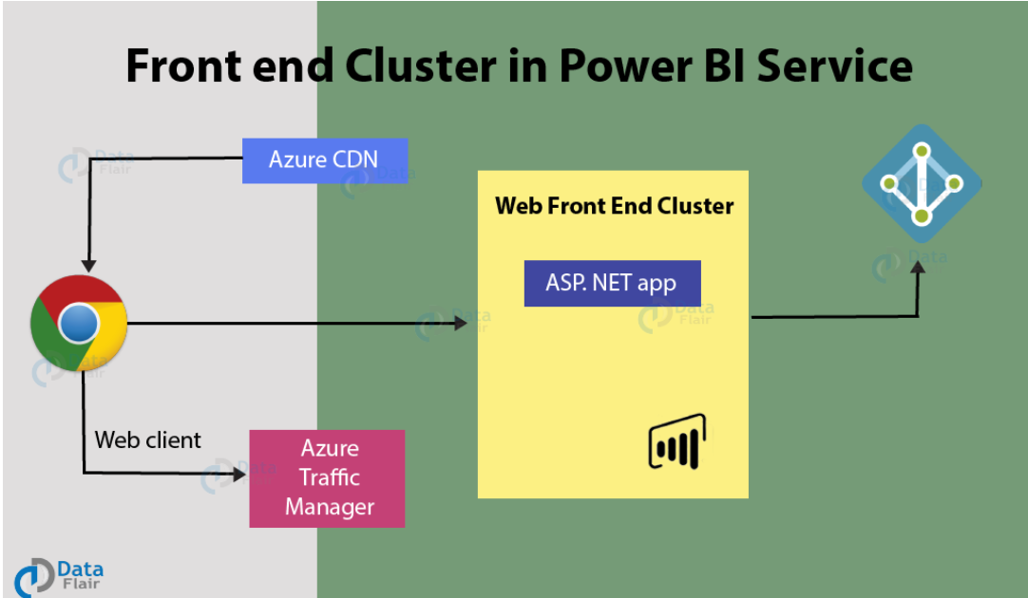

1. **Explain Back End cluster from Power BI Service Architecture**

Reports, data connectivity, data updating, and other Power BI interactions are handled by the Power BI services in the background. Only Azure API Management and Gateway Role provide direct back-end connection for a web client. For load balancing, authentication, authorisation, routing, and other functions, these two components are in charge.

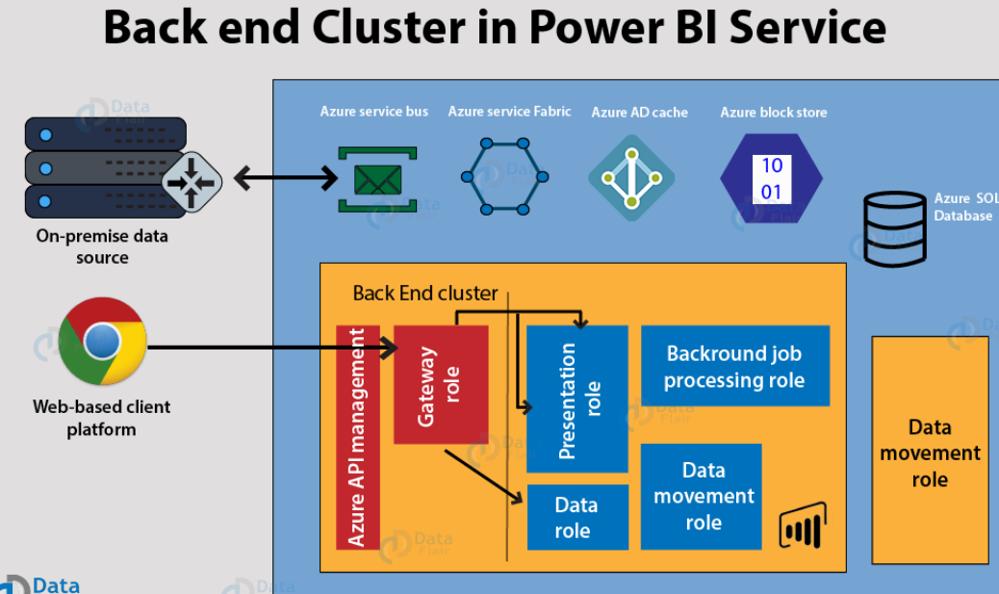

1. **What ASP.NET component does in Power BI Service Architecture?**

It is front end cluster. ASP.NET is used to build the web front end of web applications, including the Power BI Service, implementing authentication and authorization mechanisms. Also handles session management, allowing the Power BI Service to track user sessions, maintain state information, and provide a seamless user experience as users navigate through reports and dashboards.

1. **Compare Microsoft Excel and PowerBi Desktop on the following features:**

**Data import**

**Data transformation**

**Modeling**

**Reporting**

**Server Deployment**

**Convert Models**

**Cost**

1. Data import : In excel we have to refresh data manually but in PowerBi we can automatically refresh data.
2. Data transformation : We can transfer data by by using formulas and functions in excel. But in PowerBi we can use queries and tools also.
3. Modeling : In Excel data modeling is done through PivotTables and PivotCharts. In PowerBI we use excel
4. Reporting : In Excel we create reports and visualizations using charts, tables, and graphs. In Power BI we create dashboard.
5. Server Deployment : In Excel we mostly send files on online portals in Power BI we have cloud based playform
6. Convert Models : In Excel we can convert models but it takes much more adjustments and in Power BI we can convert models but not all featured will be fully converted.
7. Cost : we have to purchase license of excel to go pro. But at initial level wwe can perform all activities. Power BI is free to use. When we have to share something from Power Bi we need to take subscription.
8. **List 20 data sources supported by Power Bi desktop.**
9. Excel Workbook
10. CSV Files
11. SQL Server
12. Azure SQL Database
13. Oracle Database
14. MySQL Database
15. PostgreSQL Database
16. Access Database
17. Web
18. SharePoint Online
19. Hadoop HDFS
20. Azure Data Lake Storage
21. JSON Files
22. XML Files
23. Folder:
24. Data Feed
25. PDF Files:
26. SharePoint List
27. Azure Blob Storage
28. OData Feed